Microsoft Word Quick Guide

Keyboard Shortcuts
Must-knows
Ctrl + B | Bold selected text
Ctrl + C | Copy selected text
Ctrl + I | Italic selected text
Ctrl + S | Save the open document
Ctrl + K | Insert a hyperlink
Ctrl + V | Paste
Ctrl + V, (release) Ctrl right arrow, right arrow | Paste without formatting (click for demonstration)—or record a macro (see below, after table)
Ctrl + X | Cut selected text
Ctrl + Y | Redo the last action performed
Ctrl + Z | Undo last action
Esc | Gets you out of every jam. Anytime there’s something weird going on or a box that won’t go away for some reason, I always try escape and it always seems to work. I need an escape key for life.
Shift + left arrow or right arrow | Highlight text, character by character
Shift + Ctrl + left arrow or right arrow | Highlight text, word by word
Ctrl + = | Subscript
Ctrl + Shift + = | Superscript

Useful
Alt | Will highlight everything in the ribbon and show you the assigned letter to perform the action. This is essential to recording macros with custom keyboard shortcuts.
Ctrl + A | Select all contents of the page
Ctrl + F | Open find box
Ctrl + H | Open find/replace box
Ctrl + N | Opens new, blank document
Ctrl + L | Align left
Ctrl + U | Underline the selected text
F12 | Save as
Ctrl + Shift + * | View or hide non printing characters
Ctrl + Alt + 1 | Changes text to heading 1
Ctrl + Alt + 2 | Changes text to heading 2
Ctrl + Alt + 3 | Changes text to heading 3
F4 | Repeat the last action performed
Shift + Enter | Line break
Ctrl + Enter | Page break
Ctrl + Mouse wheel | Zooms in and out of document

I don’t use these, but maybe you’ll find them helpful
Ctrl + Shift + L | Quickly create a bullet point
Ctrl + Shift + > | Increase selected font +1pts up to 12pt and then increase font +2pts
Ctrl + ] | Increase selected font +1pts
Ctrl + Shift + < | Decrease selected font -1pts if 12pt or lower; if above 12, decreases font by +2pt
Ctrl + [ | Decrease selected font -1pts
Ctrl + <left arrow> | Moves one word to the left
Ctrl + <right arrow> | Moves one word to the right
Ctrl + <up arrow> | Moves to the beginning of the line or paragraph
Ctrl + <down arrow> | Moves to the end of the paragraph
Ctrl + Del | Deletes word to right of cursor
Ctrl + Backspace | Deletes word to left of cursor
Ctrl + End | Moves the cursor to the end of the document
Ctrl + Home | Moves the cursor to the beginning of the document
Ctrl + Spacebar | Reset highlighted text to the default font
Ctrl + 1 | Single-space lines
Ctrl + 2 | Double-space lines

Macros!
Here’s a quick screen recording of me doing what I’m about to explain
What I find to be the most useful timesaver is to create macros with custom keyboard shortcuts. Say I find myself needing to apply bold and italics to text and enlarge it a few points over and over, and I want a single keyboard shortcut to do it all. The next time some text comes up that needs that treatment, I’ll have Word record the sequence.
To do this, you choose “View” from the ribbon and, under the macros dropdown, choose “Record Macro.” If you’re creating a macro to apply formatting to text, it’s important to highlight the text before you start recording.
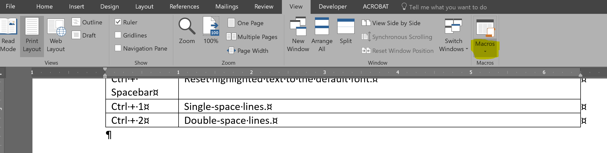
You then will assign a name and keyboard shortcut to the macro. I like to name it by what it does and what keyboard shortcut I’m assigning it. In this case, I’ll call it BoldItal14ptAltBI. (<- The red part indicates what it does, and the blue will tell me later that decided to assign it a keyboard shortcut of “Alt + B + I.”) It’s complicated to find what your assigned shortcuts are later, so you’d be well served to name the macro in a way that will help out future you.
No spaces in macro names!
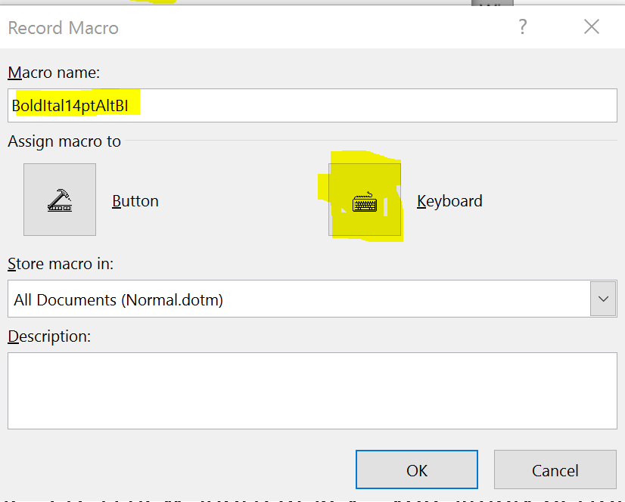
Then hit “keyboard” and, in the “Press new shortcut key” section, you simply perform the shortcut as you would if you were going to apply it. I hit “Alt + B + I” here. When you’re done, hit assign and then close. Word is now recording all your keystrokes.
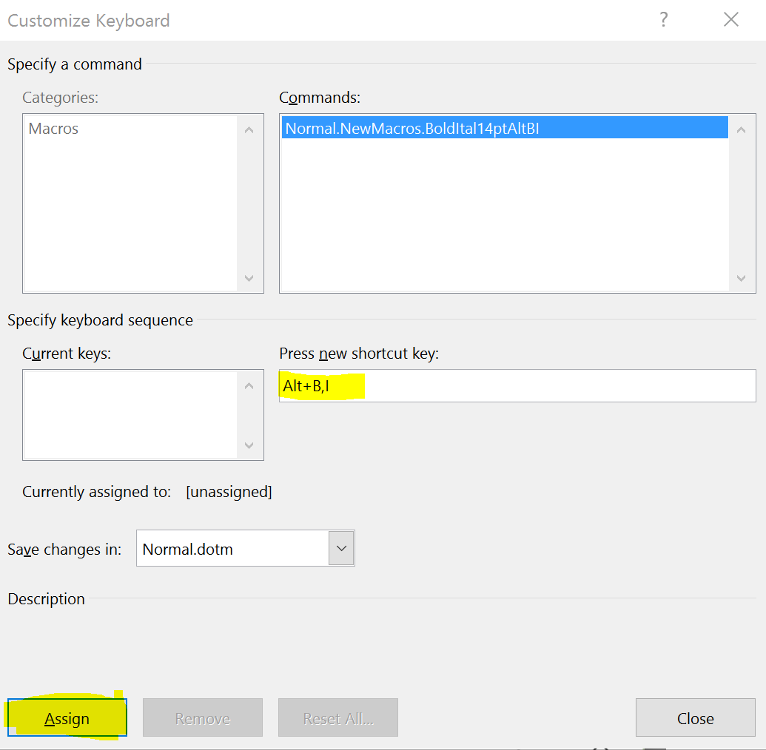
IMPORTANT: Word will not record anything you do with the mouse. That’s why it’s important to know how to do your repeatable process with the keyboard only ahead of time.
I already highlighted the text to which I wanted to apply this formatting before I started recording. Now that I’m recording, I hit “Alt,” and this shows up.
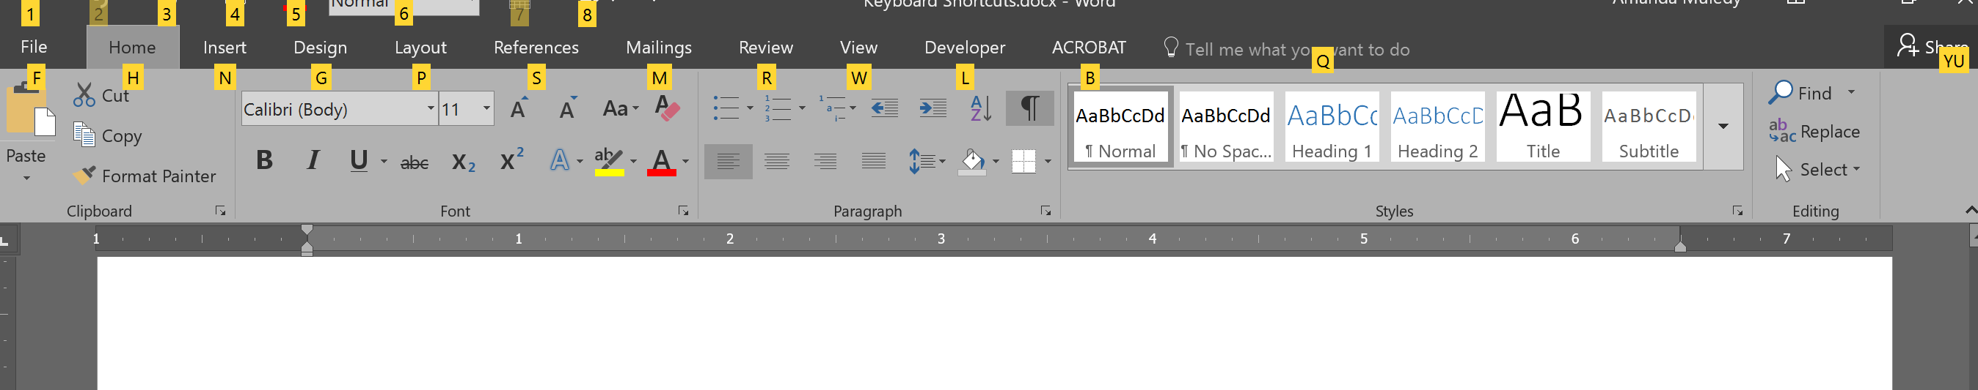
I know that the changes I want to make are in the “Home” ribbon, so I press “H.”
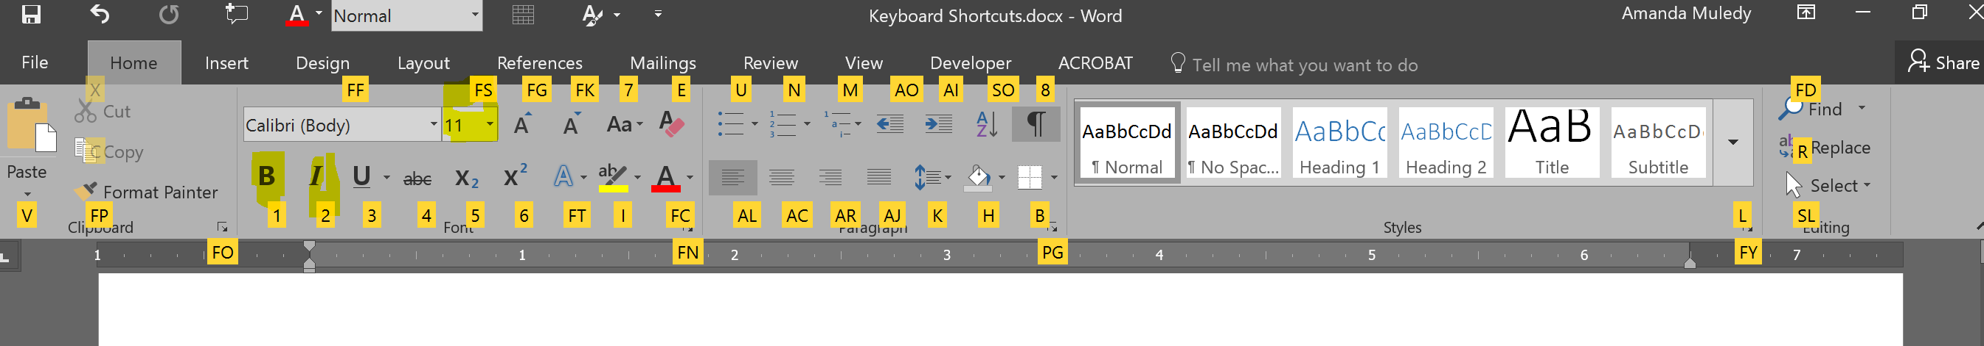
I see bold has a 1 by it, so I hit “1.” I see italics has a 2 by it, so I hit “H, 2.” And FS is font size. So I hit, “H, FS, 14, return.” Then I choose “stop recording” in the macros menu (the mouse is fine for this—you don’t need “stop recording the macro” to be part of the sequence that runs when you use the keyboard shortcut.)
That’s it. Now, when I highlight something, I can just hit “Alt + B + I” to apply formatting. This is useful any time you find yourself doing things over and over and it’s breaking your flow, such as inserting a symbol.
To take inventory of your macros, you can go to the macro menu item and choose “view.”

